Directions to:  IBIS Rotherham East, Moorhead Way, Bramley, Rotherham, S66 1YY  Tel. (01709) 730 333  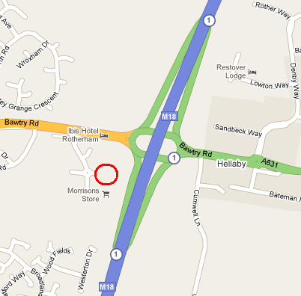  From M18 Junction 1 signposted Rotherham/ Maltby A631  Travel towards Rotherham  At first set of traffic lights (20 yards) turn LEFT just after Sir Jack’s pub towards Morrisons Supermarket.  At next mini roundabout turn left into Hotel | Anabantoid Association  of Great Britain  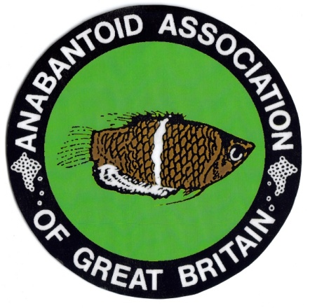 40th  Members Weekend 2nd & 3rd October 2021  IBIS Hotel, Bramley, Nr Rotherham South Yorkshire, S66 1YY. UK
Saturday Agenda  10.00 Arrival and registration.  10.50 Chairman’s welcome.  11.00 Presentation. Andrew & June Smith  Learning from experience?  12.00 Where to next? AAGB future plans. Chris Webb  12.30 Free time / Saturday auction prep  13.00 Lunch  14.00 Presentation. Dave Armitage. Title tbc  15.00 Coffee & Tea break  15.30 Presentation. Dr Peter Burgess  The Laboratory Fish  16.30 Auction -Donated to AAGB  End of formal day  Sunday Agenda  09.00 Committee meeting.  10.00 Arrival and registration.  10.30 Presentation. Andy Patel  Guinea 2020  12.00 Presentation. Kevin Webb  Spawning and development, a closer look.  13.00 Lunch  14.00 Annual General Meeting.  15.00 Coffee & Tea break. Auction preparation  15.30 Labyrinth fish auction  16.30 Non-labyrinth fish and equipment auction  18.00 Close of event  All times approximate and presentations subject to change. | Sponsorship & Support  This event would not be possible without the support of our sponsors and the goodwill of our speakers who donate their time  Fish Shows 2021  No fish shows this year but will return in 2022.  .  Auctions  This year we have added in a Saturday donated auction. Donations will be accepted for any fish, equipment and other fish related items. All profits from the sale of fish and goods will go to the AAGB.  Labyrinth fish auction (Sunday)  Fish to be booked in by Sunday morning at the latest.  15% commission will be paid to AAGB.  Non Labyrinth and other goods auction  A fish (none Labyrinth fish) plants, foods & equipment auction will take place after the main auction. Items must be booked in Sunday morning at the latest.  15% commission will be paid to AAGB.  While the AAGB will do everything reasonably possible to provide a safe environment for the fish in the auction, the decision to bring fish to the event and the welfare of the fish remains the responsibility of the owner
Booking Form  PLEASE NOTE there will be a £5 per membership charge per day to attend this event. This helps towards room hire costs and beverages.  Saturday attendance per membership £5  Sunday attendance per membership £5  Saturday buffet lunch and dessert per person £8.95 No. =  Sunday buffet lunch and dessert per person £8.95 No. =  Please book and pay for all meals in advance.  Evening meals can be purchased from several good Pubs in close proximity to the hotel  IBIS HOTEL . Accommodation rates vary significantly depending on when booked PLEASE book overnight accommodation direct with hotel or internet. Please note internet bookings may be cheaper.  (If anyone has particular difficulty please contact the secretary)  All cheques in £ sterling made payable to AAGB please to  Chris Webb.  19 Chiltern Crescent, Sprotbrough, Doncaster, South Yorkshire. DN5 7PE. UK  Tel 07940 590474  OR by PAYPAL . cjlabyrinth@tiscali.co.uk | Hello everyone  Welcome to the agenda for our next member’s weekend.  2020 and the beginning of this year have been a challenge for us all and there were times we thought that this event too would be cancelled due to the Covid virus and its restrictions.  We will work with the IBIS Hotel to make sure the venue is as safe as possible but we ask that you too take personal responsibility and PLEASE DO NOT attend if you have any signs of Covid infection or are feeling unwell.  Hand sanitiser and facemasks will be available and we encourage you to wear a mask in the lecture rooms where we are together in larger groups.  Lunch will be available on both days. However, there will be no hot Sunday lunch this year but a full sandwich buffet, chips and dessert will be available, pre book only.  The AGM will take place on Sunday 3 September at 2pm. If you have any items for the agenda, please submit them in writing to the secretary as soon as possible.  If anyone is interested in applying for any committee position again please submit your request in writing to the secretary in advance of the meeting.  Please do not hesitate to contact me if I can be of any help.  Safe journey and see you soon  Chris  Secretary and Events.  07940 590474. anabantoid-aagb@outlook.com

